COSC 304: Introduction to Databases

**Table of Contents**

*Jersey n EM - report*

Developed by (Group 7): Harper Kerstens, Aaron Hong

Date: 12-06-2024

GitHub Repo: <https://github.com/harperkerstens/304_project>

Website: <http://57.151.104.13>

*Instructor: Dr. Ramon Lawrence*

*UBC Okanagan | 3333 University Way, Kelowna, BC V1V 1V7*

**TITLE PAGE**…………………………………………………………………………………………………….**1**

**MISSION STATEMENT**………………………………………………………………………………………..**3**

**EXECUTIVE SUMMARY.**……………………………………………………………………………………..**3**

**DEVELOPMENT FEATURES**……..………………………………………………………………………….**4**

**WALKTHROUGH - CUSTOMER**…………...………………………………………………………………..**6**

**HOMEPAGE**…………………………………………………………………………………………….6

**LOGIN/USER INFO**…....……………………………………………………………………………….7

**PRODUCT LIST**…..…………………………………………………………………………………….8

**CART/CHECKOUT**………………………………………………………………………………….....9

**WALKTHROUGH - ADMIN**…………...……………………………………………………………………..**10**

**ADMIN DASHBOARD**……...…………………………………………………………………………10

**SALES REPORT**…….…………………………………………………………………………………11

**ADD/EDIT PRODUCT**…………...……………………………………………………………………12

**SOURCES**…………………………..……...…...……………………………………………………………….**13**

**Mission Statement:**

At Jersey N Em, we’re dedicated to bringing fans closer to the game by making it easy to find jerseys of your favorite players, no matter how unique. Frustrated by the limited selection in Canada, we set out to create a one-stop shop for basketball enthusiasts who want more than just mainstream options. Whether you're repping a rising star, a legend, or an underdog, we’re here to help you wear your passion proudly.

**Executive Summary:**

Jersey N Em is an online platform revolutionizing the way Canadian basketball fans connect with their favorite players through authentic, hard-to-find jerseys.

Founded by lifelong friends who bonded over music and hoops, Jersey N Em was born out of a shared frustration: the difficulty of finding jerseys of their favorite players in Canada, where only mainstream options dominate the market. Our mission is to provide a diverse range of jerseys, celebrating both star players and lesser-known athletes. Driven by our love for the game and the community it builds, we’re dedicated to helping basketball enthusiasts connect with their idols and showcase their pride.

With a focus on quality and authenticity, our company strives to build a reputation as a trusted source for basketball apparel. Beyond selling jerseys, we aim to foster a global community of fans who celebrate every player, from unsung heroes to iconic legends. Jersey N Em is a reflection of our journey, from schoolyard conversations about basketball to becoming business partners united by a shared dream. Together, we’re creating a space where fans can find the jerseys they love and be part of a community that values every player and every story, redefining what it means to represent the game…

Project Features

|  |  |  |  |  |
| --- | --- | --- | --- | --- |
| **Final Overall System Features** | **Category** | **Possible Points** | **Points** | **Comments / Code Files** |
| **Documentation (15 total points)** | | | | |
| Executive Summary (up to 1 page) | Core | 2 | 2 | JerseyNEmDocumentation.docx |
| System Features (2 pages) | Core | 2 | 2 | JerseyNEm Documentation.docx |
| List of Web and AI sources used | Core | 3 | 3 | JerseyNEm Documentation.docx |
| Walkthrough with screenshots (up to 15 pages) | Core | 8 | 8 | JerseyNEm Documentation.docx |
|  | | | | |
| **Hosting (10 total points)** | | | | |
| Running on cloud server | Advanced | 10 | 10 | Hosted using Azure on <http://57.151.104.13> |
|  | | | | |
| **Main/Home Page (up to 14 total points)** | | | | |
| Search for a product by name | Core | 1 | 1 | Listprod.js |
| Browse products by category | Core | 1 | 1 | ListTeam.js and team.js |
| List products (by search/browse) | Core | 1 | 1 | Listprod.js |
| List products with image | Core | 1 | 1 | Listprod.js and team.js |
| Page header with menu | Basic | 1 | 1 | Header.js |
| Page header shows current logged in user | Basic | 1 | 1 | Shown on frontpage, index.handlebars |
| Dynamic products on page based on sales | Basic | 2 |  |  |
| Improved UI (user-friendly, images, etc.) | Basic | 2 | 2 | Shown on frontpage, index handlebars |
| Product recommendation based on user | Advanced | 4 |  |  |
|  | | | | |
| **Shopping Cart (up to 8 total points)** | | | | |
| Add to shopping cart | Core | 1 | 1 | Addcart.js |
| View shopping cart | Core | 1 | 1 | Showcart.js |
| Update quantity (with data validation) | Basic | 1 | 1 | Showcart.js |
| Remove item from shopping cart | Basic | 1 | 1 | Showcart.js |
| Improved formatting/UI (e.g. in header bar) | Basic | 1 | 1 | Showcart.js |
| Cart stored in database between sessions | Basic | 3 |  |  |
|  | | | | |
| **Checkout (up to 9 total points)** | | | | |
| Checkout with customer id | Core | 1 | 1 | Checkout.js |
| Checkout with payment/shipment info | Basic | 2 |  |  |
| Checkout with data validation | Basic | 2 |  |  |
| Multiple shipments per order supported | Advanced | 2 |  | Note: Requires DB change. |
| Calculate taxes/shipping (by items/state) | Advanced | 2 |  | Note: Requires DB change. |
|  | | | | |
| **Product Detail Page (up to 2 total points)** | | | | |
| Product detail page and item description | Core | 1 | 1 | Product.js |
| Product detail has an image from database | Core | 1 | 1 | Product.js |

|  |  |  |  |  |
| --- | --- | --- | --- | --- |
| **User Accounts/Login (up to 12 total points)** | | | | |
| Create user account page | Basic | 2 | 2 | createAccount.js |
| Create account with data validation | Basic | 2 | 2 | createAccount.js |
| Edit user account info (address, password) | Basic | 2 | 2 | Customer.js |
| Login/logout | Core | 1 | 1 | Available on frontpage, index.handlebars |
| Register user/Forgot password email | Advanced | 4 |  |  |
| Page listing all orders for user | Core | 1 | 1 | Customer.js |
|  | | | | |
| **Product Reviews (up to 5 total points)** | | | | |
| Ability to enter a review on a product | Basic | 2 |  |  |
| Display product review on product detail page | Basic | 1 |  |  |
| Restrict to one review per user on item purchased | Advanced | 2 |  |  |
|  | | | | |
| **Warehouses/Inventory (up to 5 total points)** | | | | |
| Display item inventory by store/warehouse | Basic | 2 |  |  |
| Edit item inventory by store/warehouse | Advanced | 3 |  |  |
|  | | | | |
| **Administrator Portal (up to 19 total points)** |  |  |  |  |
| Secured by login | Core | 1 | 1 | Admin.js |
| List all customers | Core | 1 | 1 | Admin.js |
| List report showing total sales/orders | Core | 1 | 1 | Listorder.js for all orders, admin.js for reports |
| Report with a graph | Advanced | 3 | 3 | Admin.js |
| Add new product | Basic | 2 | 2 | Admin.js |
| Update/delete product | Basic | 2 | 2 | Admin.js |
| Change order status/ship order | Basic | 1 |  |  |
| Upload a photo to file system for product | Advanced | 2 | 2 | Admin.js |
| OR: Upload a photo to database for product | Advanced | 4 |  |  |
| Database restore with SQL script | Basic | 2 | 2 | Admin.js |
| Add/update warehouse, customer | Basic | 2 |  |  |
|  |  |  |  |  |
| **Database System/General** |  |  |  |  |
| Implement some validation using triggers | Advanced | 2 |  |  |
| Use AJAX for some pages | Advanced | 4 |  |  |
| User interface and navigation/usability |  | Up to 5 |  |  |
| *Others (your suggestions)* |  | Up to 5 |  |  |
|  |  |  |  |  |
|  |  |  |  |  |
|  |  |  |  |  |
| **Total: (out of 50 with maximum of 10 bonus marks. i.e. 60 points out of 50 is max.)** |  | 60/50 |  |  |

Walkthrough - Customer

1. HOMEPAGE - CUSTOMER

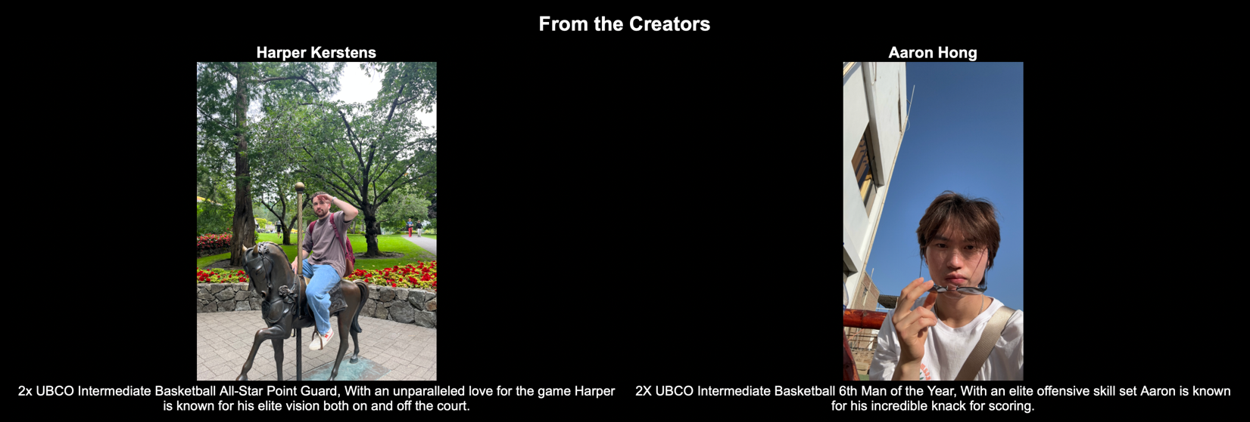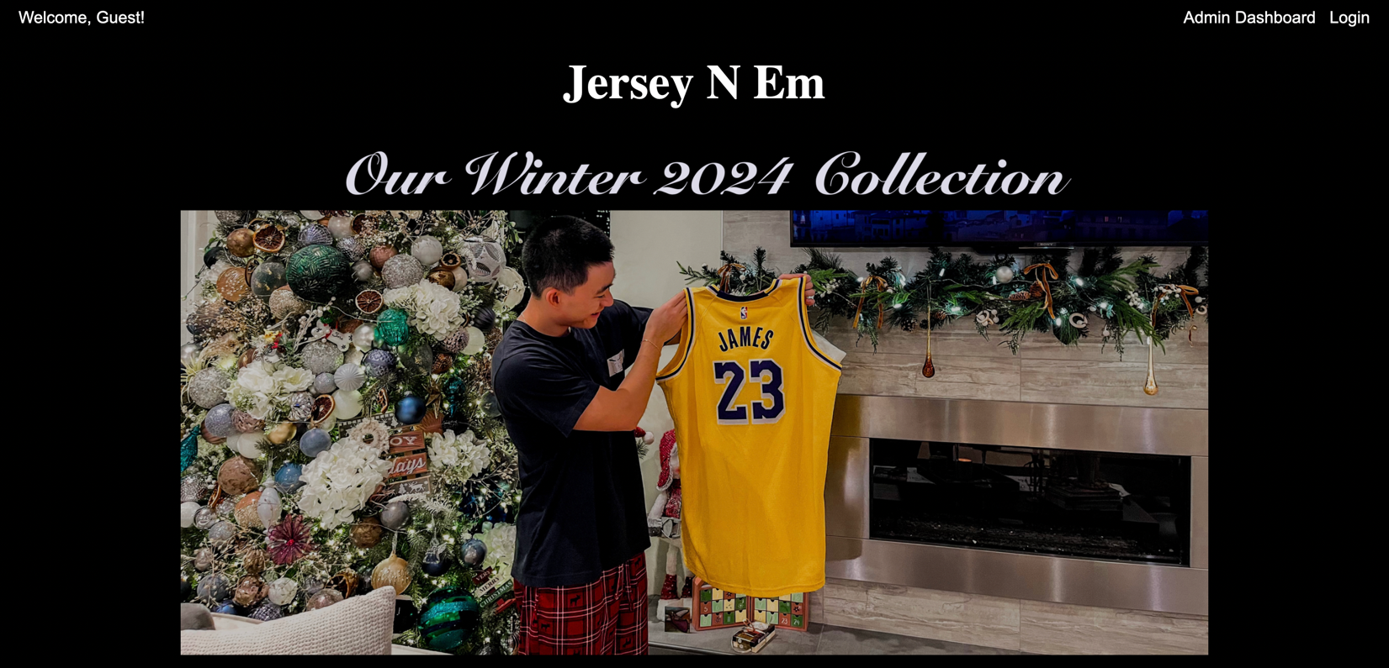

1.1 Our Homepage for Jersey N Em, we use a sleek looking jet black for the background. Up top we have the homepage navigation which allows for admin access as well as login, and the image for “Our Winter 2024 Collection” is a link that floats once the mouse hovers over the image (you won’t miss it), when clicked it will take you to the list of NBA teams by conference (Eastern and Western). We will first go over the log in feature.

1. LOGIN/USER INFO - CUSTOMER

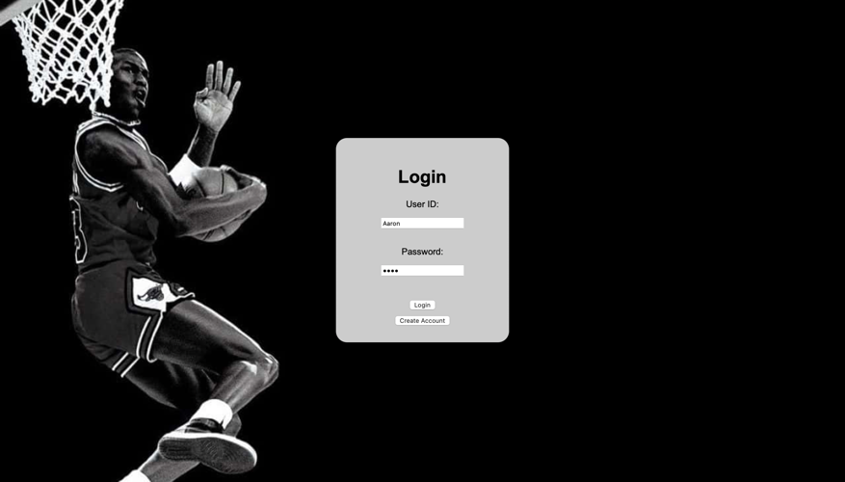

2.1 Here is the login page which was directed from the nav bar in the home page, it has the option that allows for users to sign up or sign in if there they are existing customer (saved in DB).

2.2 Here is what it looks like when creating an account with us, this information is saved to our database and can be edited in the future as well. *All fields are required to allow account creation

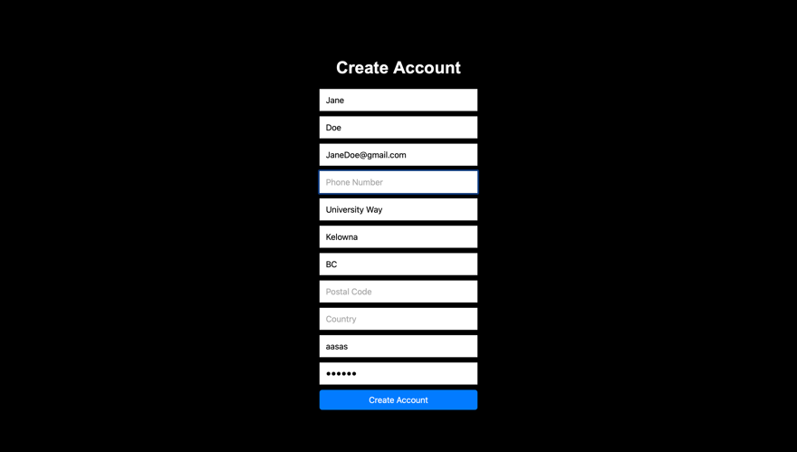

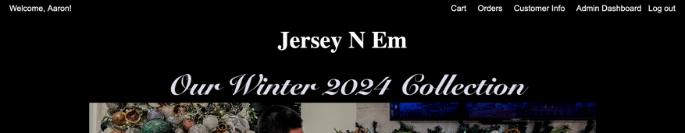

2.3 Once Logged we welcome you by the first name of your account, and the nav bar now shows Cart, Orders, Customer Info, Admin Dashboard and Logout.

2.4 This is the customer info section which shows all the field. From here you can update your information which is saved to our database, you can also change your password on the bottom left.

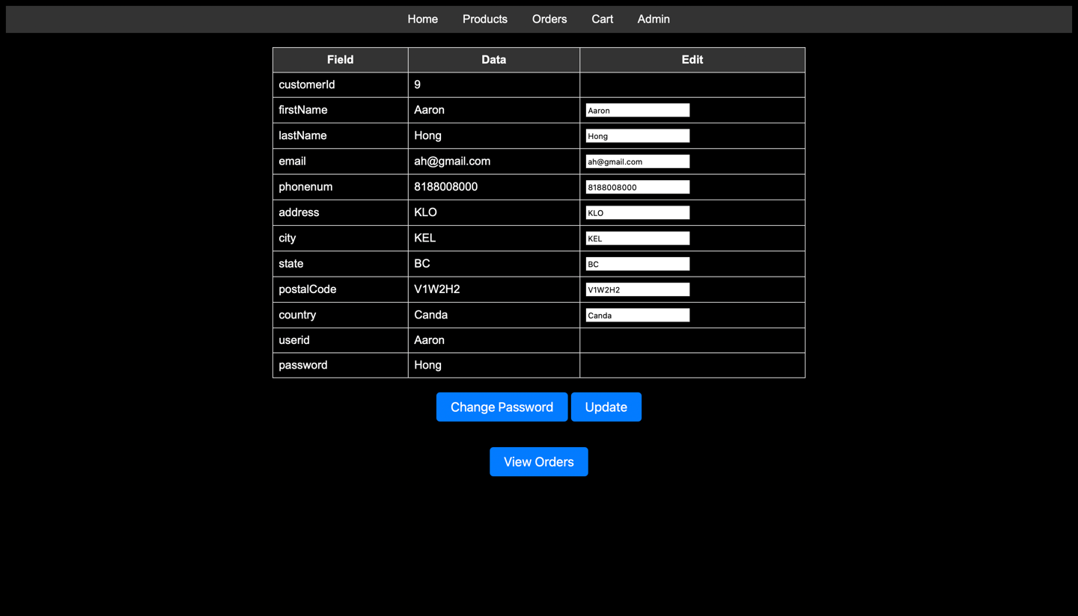

1. PRODUCT LIST – CUSTOMER

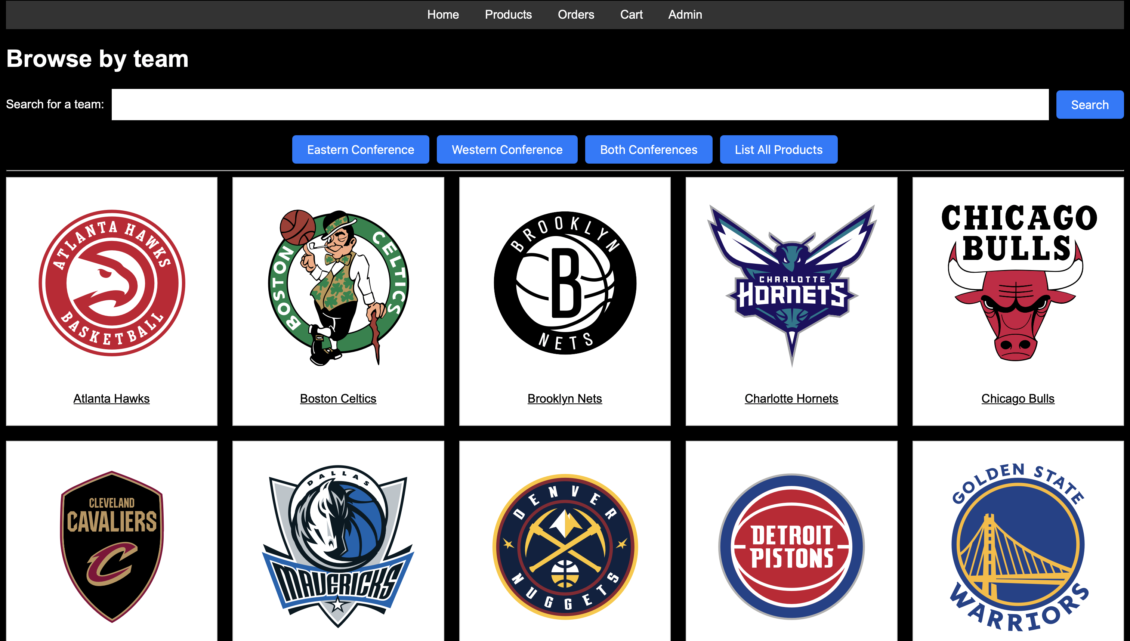

3.1 After clicking on the “Our Winter 2024 Collection” image from the homepage it directs you to the different NBA teams which can be sorted by conferences. You are also able to search for team of your interest and these links will take you to our player jerseys depending on the team they are/were in. If you are looking for just a list of all the products we offer “List All Products” can be clicked.

3.2 Here is what the product page looks like for the Chicago Bulls, including current and historic jerseys and you may filter between the two.3.3 Here is the page for when you click on a jersey of interest, it gives you a quick description of the player and ability to add to cart

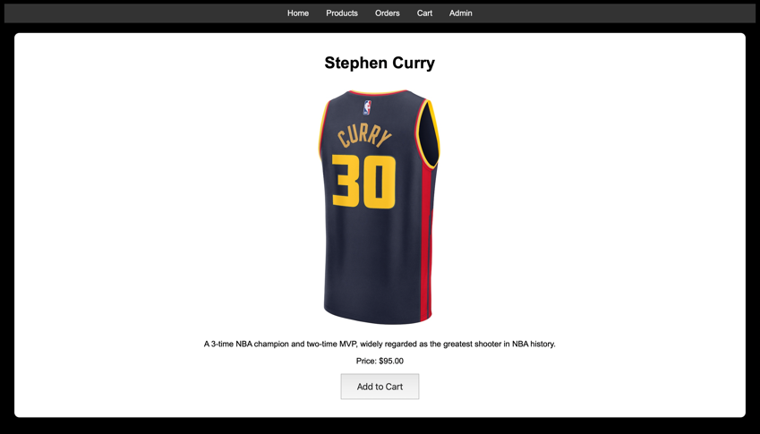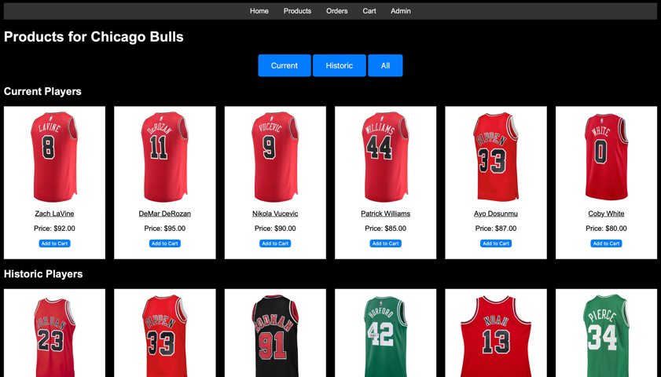

1. CART/CHECKOUT – CUSTOMER

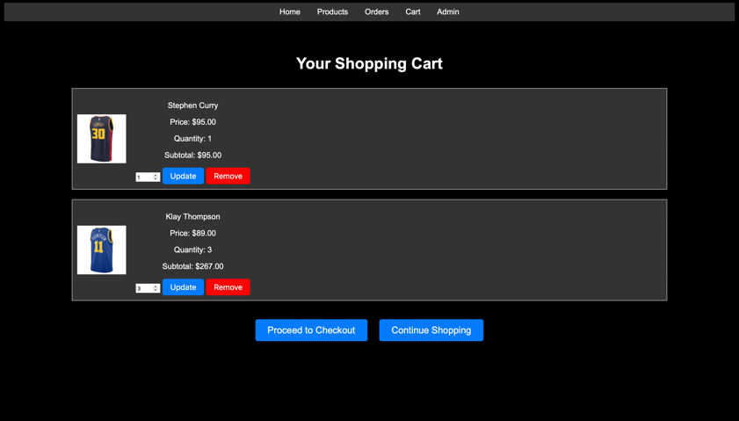4.1 After adding our product to your cart, you can change the quantity as well as remove anything change your mind on within your cart.

4.2 After pressing “Proceed to Checkout” we will show your entire cart before you proceed.

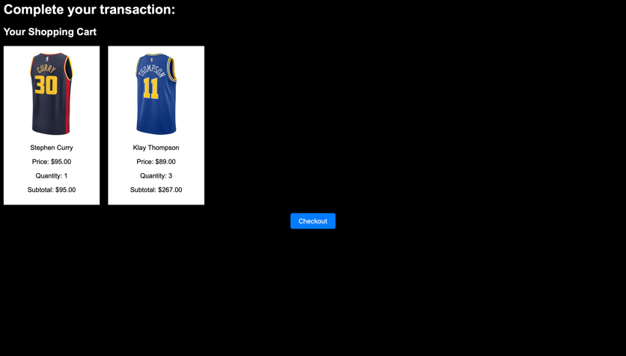

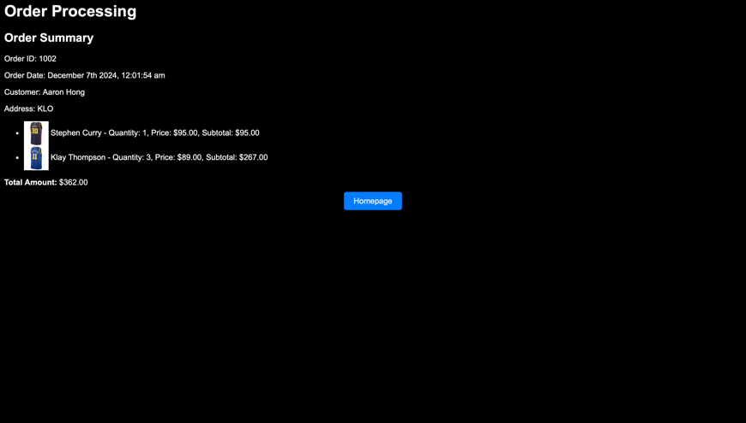

4.3 Once you complete looking over your order it will direct you to your order summary and process

your order. It will now show your shipping address order date as well as order id. Showing that you have placed an order with us.

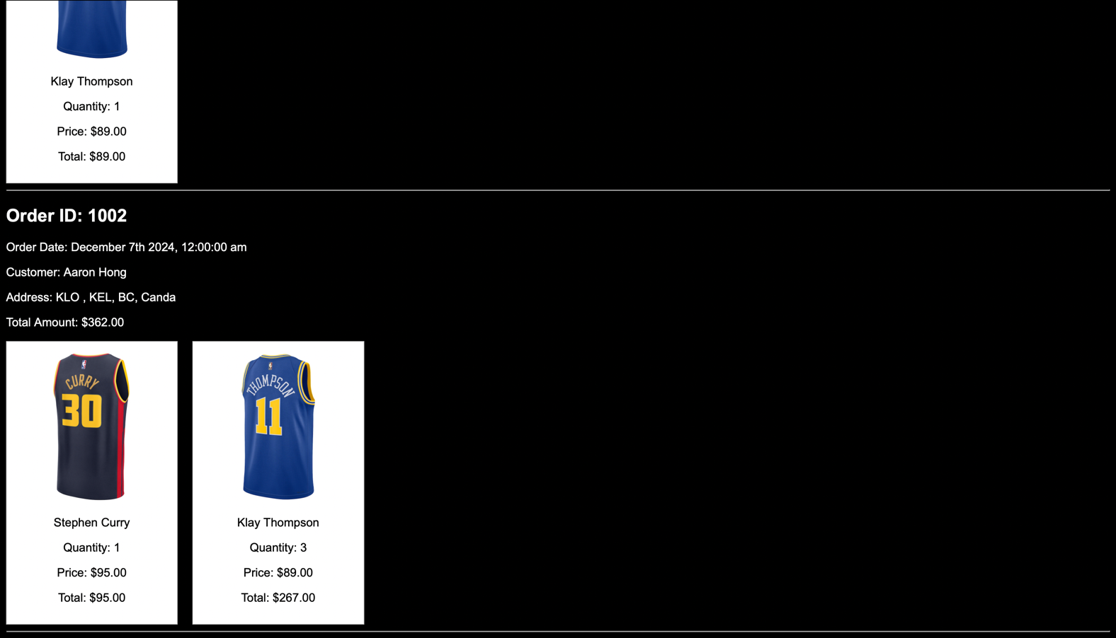4.4 After that we can check all your placed orders in the “Orders” tab located in the nav bar in the homepage.

Walkthrough - Admin

1. ADMIN DASHBOARD – ADMIN

5.1 From the admin dashboard we can list all the customers and their info, go into the sales report as well as add/edit jerseys and restore the data back into the default state.

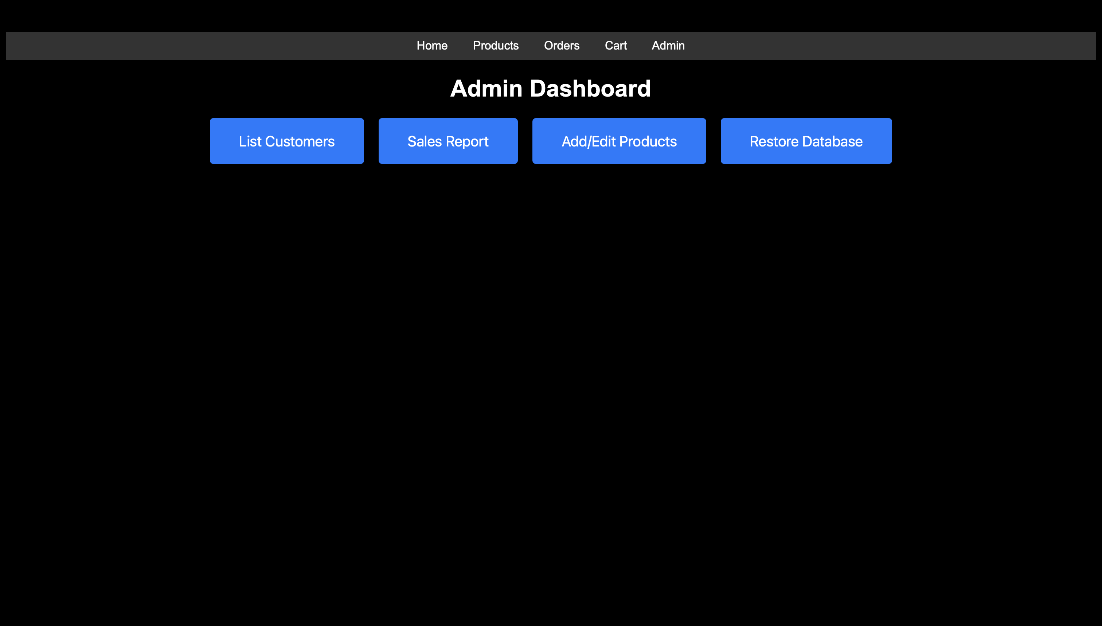

5.2 Here is what the list customers page looks like within admin portal. It shows all our customers information in one page and are differentiated by their customerID (PK).

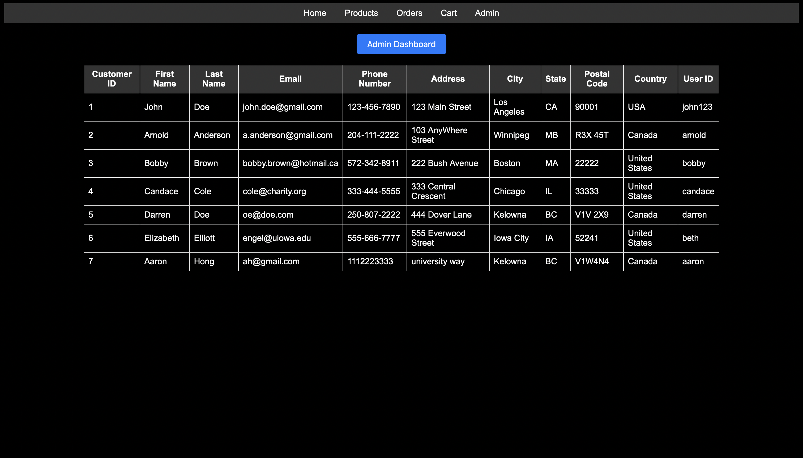

1. SALES REPORT – ADMIN

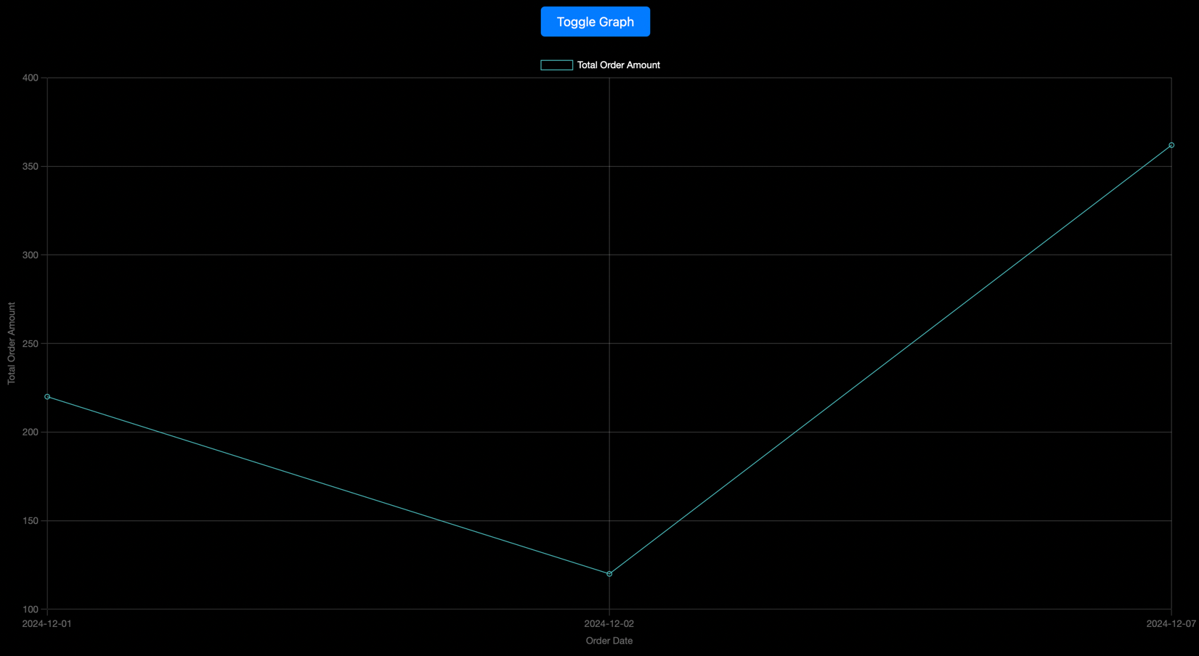

6.1 Here is our sales report graph which shows the total order amount by date, and we can see that our previous purchase was logged into our database and shows that the transaction went through. This can be useful to compare sales between days and can help us understand the demand, something we may implement later is what our best-selling item is and go off popularity for what items to stock and which ones we don’t need to order more of to keep our warehouse space optimal.

1. ADD/EDIT PRODUCT - ADMIN

7.1 From this page we are able to add entirely new jerseys for new players or ones we don’t have listed yet. There is also an edit button which allows the admin to make changes to the products we currently have listed.



7.2 For adding a new jersey we will demonstrate by adding Dr. Ramon Lawrence into our DB with the product name, price, description, player status and team. Finally, we added his jersey image (must be jpg for now).

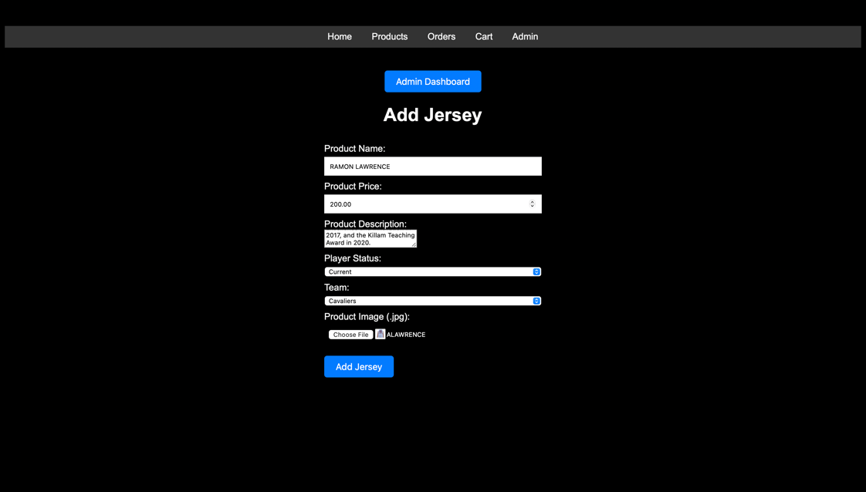

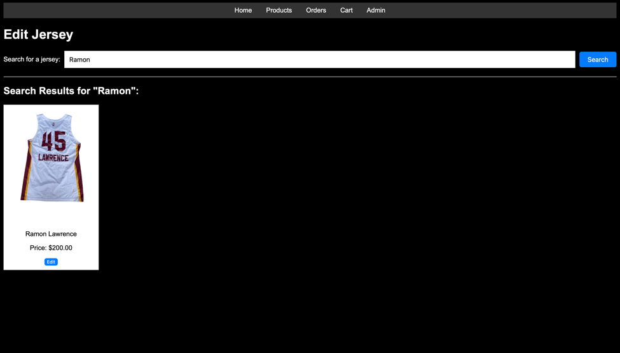7.3 After adding the product, we can now go to “edit jerseys” to look for Dr. Lawrence’s jersey.

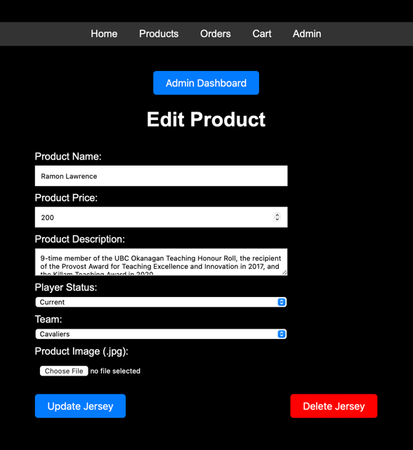7.4 Here is what the edit page looks like, similar to add page but gives you potion to update current info or delete the jersey

Sources

AI:

<https://chatgpt.com/share/6752bbbf-114c-8006-9098-7f1b98bdd809>

<https://chatgpt.com/share/6752bbf5-49c4-8006-86ad-ed47d007590c>

<https://chatgpt.com/share/6752bc07-8090-8006-82b1-409cdfec1a10>

WEB:

<https://www.w3schools.com/cssref/sel_hover.php>

<https://www.w3schools.com/cssref/atrule_font-face.php>  
<https://www.nbastore.ca>

<https://www.mitchellandness.com/en/>

<https://www.w3schools.com/css/>

<https://www.w3schools.com/howto/howto_css_two_columns.asp>

<https://www.w3schools.com/css/css_templates.asp>

<https://www.w3schools.com/nodejs/nodejs_filesystem.asp>

<https://www.w3schools.com/nodejs/nodejs_uploadfiles.asp>

<https://www.w3schools.com/ai/ai_chartjs.asp>